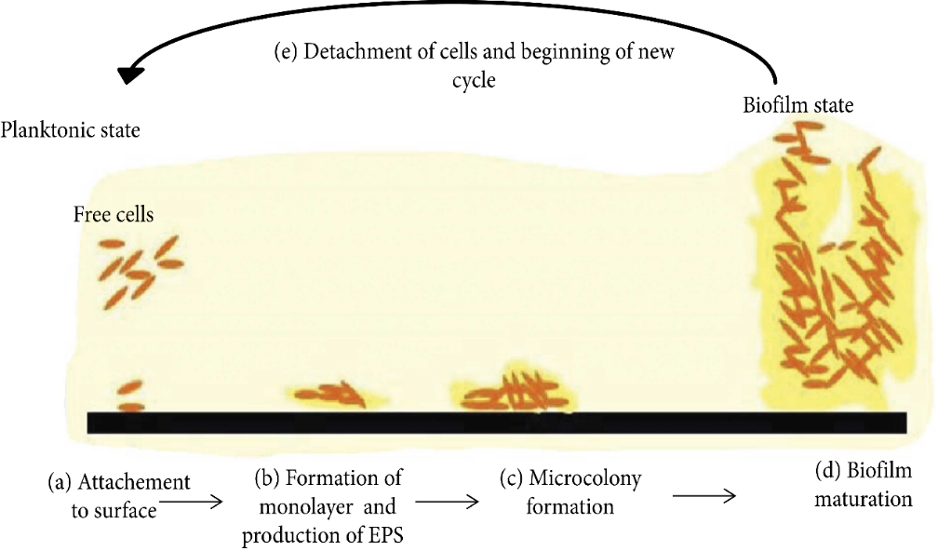
Fig. 1: Stages of biofilm formation (13)

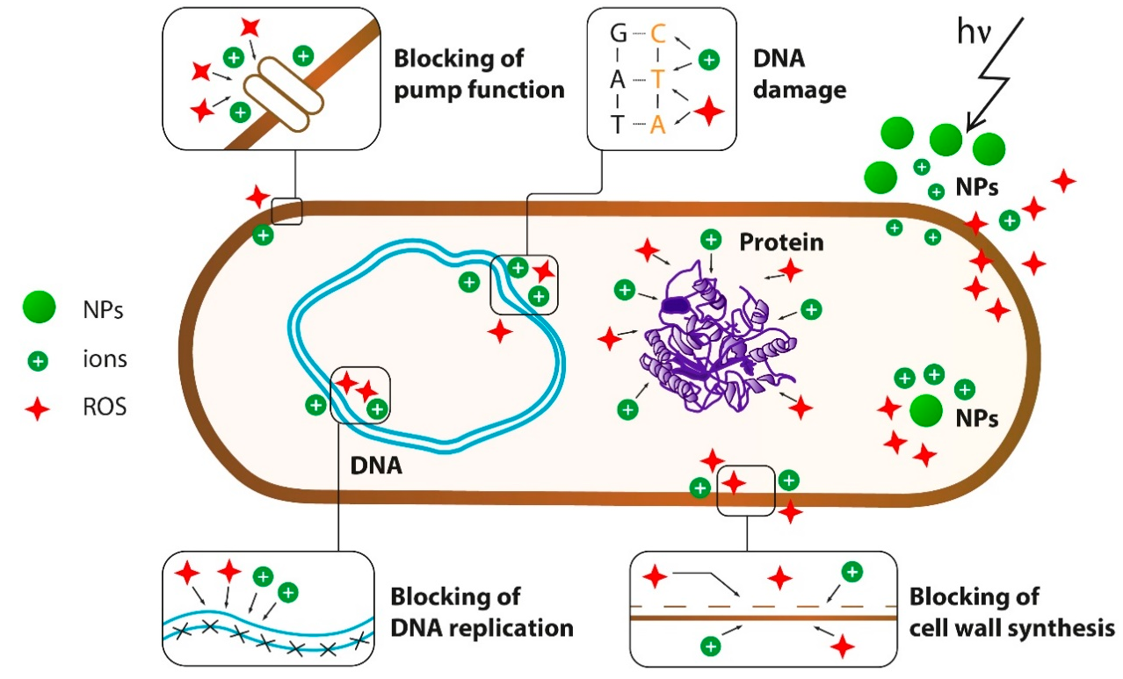
Fig. 2: Actions of metal oxide nanoparticles on bacterial cell.
Brown line: cell surface (cell wall and membrane), blue line: DNA, and arrow: electromagnetic irradiation ⁽²¹⁾

