The Central Role of the Physician-Scientist in
Translational Medicine. An Overview.

Hassan M. Elnady

Department of Neurology and psychological medicine, Faculty of Medicine, Sohag University, Sohag, Egypt.

Abstract
The model of the physician who uses research to try to solve the mystery of the disease has existed throughout the ages, starting from the era of Hippocrates, through the Middle Ages, and up to the present day. The terms "physician-scientist," "clinical-scientist," and "clinician-scientist" have all been used to refer to medical practitioner who works in a position between clinical practice and research. Due to their knowledge of both science and medicine, physician-scientists are able to pose clinically pertinent research questions and integrate scientific inquiry into patient care. They provide a distinct viewpoint to biomedical research. Basic science principles are a prerequisite for physician-scientists. Translational medicine is a two-way concept that includes both bench-to-bedside factors, which work to improve the speed at which new therapeutic strategies developed through basic research are tested in clinical settings, and bedside-to-bench factors, which offer feedback on how new treatments are being used and how they can be made better. The institutional divide between the clinic and the lab is where physician-scientists are expected to stand, with one foot in each. They serve as a bridge between the two different worlds, where differences in language and training can make communication challenging. Physician-scientists act as catalysts for translational research. Physician-scientists collaborations enhance patient care, advance medical education, and improve the biomedical industry's profitability.
Keywords : physician-scientist; Translational medicine; bedside-to-bench; biomedical research
DOI: 10.21608/smj.2023.238315.1416
*Correspondence : hass_elnady@yahoo.com

Received: 24 September 2023
Revised: 29 November 2023
Accepted: 29 November 2023
Published:01 January 2024

Introduction

In the midst of our studies of medicine, we came across many names that we did not care about studying the nature and history of them, including but not limited to Charcot (in Charcot’s triad) and Golgi (in Golgi apparatus). Studying the history and nature of these figures represents an important basis for development in the medical field.
With at least 13 diseases bearing his name, the French physician Jean-Martin Charcot (1825–1893) is perhaps one of the most significant physicians in the history of modern medicine. Originally a pathologist, Charcot recognized the relationship between anatomical and clinical findings. By utilising this method, it was possible to correlate the clinical traits with the pathological changes of several disorders (e.g. multiple sclerosis and amyotrophic lateral sclerosis).⁽¹⁾
The Italian physician and biologist Camillo Golgi (1843–1926) was among the medical graduates who chose research as a career path, but also practiced clinical medicine. He created a number of significant discoveries that bear his name today (e.g., the Golgi tendon organ, and the cytoplasmic Golgi apparatus). Together with the Spanish physicist Santiago Ramon y Cajal, Camillo Golgi was awarded the Nobel Prize in 1906.⁽²⁾
In fact, the model of the physician who uses research to try to solve the mystery of the disease has existed throughout the ages, starting from the era of Hippocrates, and up to the present day.⁽³⁾
The Middle East succeeded during the Middle Ages in presenting such wonderful models.⁽⁴⁾
One of them was the brilliant Islamic physician Ibn al-Nafis, who was first discovered in the West in the 20th century (Ca. 1210-1288), who made outstanding anatomic discoveries while bravely questioning Galenic dogma. Most significantly, he established the existence of a heart-lung circulation by asserting that blood cannot flow directly from one side of the heart to the other.⁽³⁾
With the beginning of the nineteenth century, most European countries, especially Germany, succeeded in bringing about a radical change in medical education by including laboratory training for medical students alongside clinical training.⁽³⁾ This explains the Europeans' acquisition of most of the Nobel Prizes in medicine during the first third of the twentieth century.⁽⁵⁾

The development of the concept
In his presidential address to the first meeting (in 1909) of the Association for the Advancement of Clinical Research (now the American Society for Clinical Investigation), Samuel Meltzer (an American physiologist) elaborated the concept of the physician-scientist.⁽⁶⁾ According to him, researchers in the field of clinical medicine "must have a training fitting them to carry out investigations in conformity with the requirements existing in all pure sciences" and that the field will not advance through chance investigations by friendly neighbours from the adjacent practical and scientific domains.⁽⁶⁾
One year later (in 1910), the Rockefeller Institute for Medical Research Hospital was founded. The first director of the Rockefeller Hospital was Rufus Cole, an American physician and clinical researcher. By pressing that the physicians at the Rockefeller Institute Hospital be given access to bench research space and resources, he was able to successfully advance the notion of the physician-scientist against significant opposition.⁽⁷⁾
Proceeding from this beginning - with clear features - represented by launching the correct concept of the cadre in 1909 and insisting on producing him/her in 1910, the United States succeeded in producing increasing numbers of physician-scientists.
Moreover, the United States pioneered the combined MD/ PhD programme in 1950s as a new curriculum for training physician-scientists.⁽⁸⁾
Typically, the programme lasts eight years. During that time, undergraduate medical students finish the first two years of medical school, spend four years working on full-time research, and then return to finish the final two years of their medical degree (i.e., 2 + 4 + 2).⁽⁹⁾
As of 2016, there were 120 MD/PhD programs available at US medical schools.⁽⁹⁾
Since the introduction of the combined degrees, there have been two main sources of physician scientists in the US: those who begin combined MD and PhD training upon entering medical school, and the so-called "late bloomers," who begin extended research training only after finishing medical school, residency, or clinical subspecialty training.⁽¹⁰⁾ Late bloomers are undoubtedly considered the classic models (physicians who, later in their careers, discover a talent for research).⁽¹¹⁾

The concept of physician-scientist in literatures
The paragraphs that follow illustrate the idea of the physician-scientist in previous writings. Although some of them may sound similar, each one may provide the reader a different viewpoint that will help him/her better understand what a physician-scientist is like.
The terms "physician-scientist," "clinical-scientist," and "clinician-scientist" have all been used to refer to medical practitioner who works in a position between clinical practice and research. ⁽¹²⁾
Thought leaders have spent years considering who and what the physician-scientist should be.⁽¹³⁾
The term physician-scientist is one of those compound words that have been created to unite disparate elements. Although the hyphen (-) makes it easier to keep the words together, it is unable to hide the internal conflicts. That is the fundamental difference between physicians and scientists. The union required to become a physician-scientist can take years to establish and is frequently tenuous and unsettling. Physician-scientist has two interesting features as a compound word. The first is that a person of action—a physician—and a person of thought—a scientist—are described together. The second feature is that the two words' order seems to matter; the action person comes before the thought person.⁽¹⁴⁾
Physician-scientists are medical professionals whose main line of work involves biomedical research. The pathophysiologic mechanisms that reveal methods for disease diagnosis, prevention, and therapy are frequently the subject of their research.⁽¹⁵⁾
Physician-scientists are defined as "... those considered to be clinicians by physiologists, biochemists, and immunologists; and considered to be physiologists, biochemists, or immunologists by most clinicians... " ⁽¹⁶⁾
Why is it necessary for physicians to become scientists? Andrew I. Schafer provided the answer to this question, reporting that what makes physicians so exceptional is that they address research questions in a unique way because they are inspired by their own experiences providing care for patients.⁽¹⁷⁾
Physician-scientists provide a distinct viewpoint to biomedical research.⁽¹⁸⁾ They are in a good position to play an important role in bringing the advantages of research to patients as well as clinical viewpoints to the laboratory.⁽⁸⁾
Basic science principles (such as those found in molecular biology, genetics, systems biology, etc.) are a prerequisite for physician-scientists.⁽¹⁹⁾
A sizable portion of the major prizes for biomedical research has gone to physician-scientists, including 61% of the Lasker Awards for clinical science and 41% of the Lasker Awards for basic science, as well as 37% of the Nobel Prizes in Physiology or Medicine.⁽¹⁸⁾
Since physician-scientists are crucial to the reputation and success of major medical schools, such institutions should invest in their future.⁽²⁰⁾ However, these institutions should keep in mind that effective physician-scientist research requires protected time.⁽¹⁹⁾
In many cases, physicians who head clinical departments at the greatest institutions in the world—Harvard, Cambridge, Oxford, and Johns Hopkins—are physician scientists who also operate their own research labs.⁽²¹⁾
Rigorous scientific inquiry, directed by qualified physician-scientists, has benefited all clinical disciplines and should continue to do so, enhancing overall patient health through discovery.⁽¹¹⁾

The 1979 paradox and categorization of physicians
James Wyngaarden, who later became head of the National Institutes of Health (NIH), issued a grim warning in a 1979 article that physicians who specialized in research were "an endangered species."⁽²²⁾
James Wyngaarden titled the article “The Clinical Investigator as an Endangered Species” but then added: “There is a paradox in that title". He was referring to the contradiction that by the end of the 1970s, there were more academic physicians working full-time in the United States than there had ever been. With regard to the clinical investigator, the author focused particularly on the physician-scientist. As a result, he referred more to the physician who is also a serious scientist than to the clinician who might occasionally conduct some research.⁽²²⁾
Regardless of James Wangarden's article's primary subject, there is another lesson to be drawn from it, and that is the categorization of physicians into three groups. These groups are as follows:
- Physician-scientist: a someone who has had extensive training in both clinical medicine and a scientific field, and who further engages in both clinical and experimental endeavours as a career role.⁽²²⁾
- Clinical investigator: the clinician who may occasionally also do some research (apart from that done by Physician-scientist).⁽²²⁾
- Obviously, the third group will be the Physician who is not interested in research and will be called in my article the practicing Physician.
However, the three groups overlap rather than being distinct because they are all supposed to practise clinical medicine. Or, to be more precise, physician-scientists are considered a subgroup of clinical investigators, and clinical investigators are considered a subgroup of practicing physicians (figure 1)
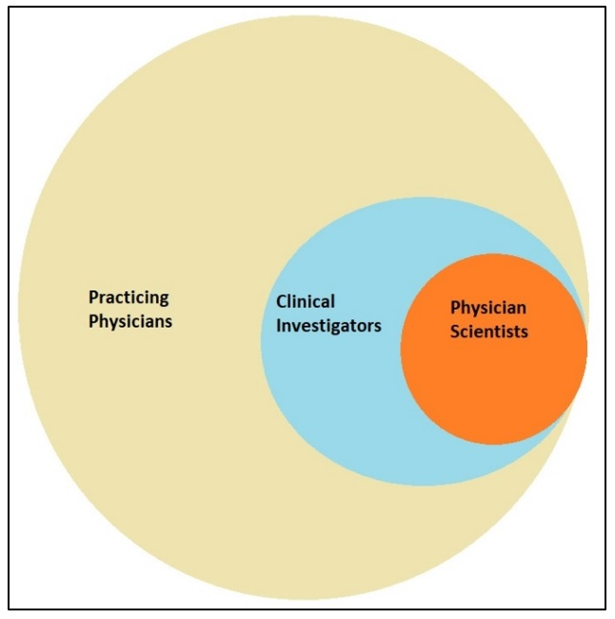

Fig. 1. Categorization of physicians depending on their research preferences.

How does a physician-scientist arrive to a discovery?
Joseph L. Goldstein (a prototypical physician-scientist and a Nobel Prize laureate) presented an equation for how a medical discovery could be achieved by a physician-scientist and applied this equation to three historical physician-scientists.⁽²³⁾
The equation is: Clinical stimulus × basic scientific training = fundamental discovery ⁽²³⁾
For Archibald E. Garrod (1857-1936, Father of Biochemical Genetics) the clinical stimulus was black urine, the basic scientific training was chemistry and the resultant discovery was one gene encodes one enzyme. For Karl Landsteiner (1868-1943, Father of Immunochemistry) the clinical stimulus was the transfusion reactions, the basic scientific training was chemistry and the resultant discovery was ABO blood groups; principles of immunochemistry. For Rudolf Schoenheimer (1898-1941, Father of Molecular Biochemistry) the clinical stimulus was hypercholesterolemia and atherosclerosis, the basic scientific training was chemistry and the resultant discovery was isotopes as tools for biological research; theory of dynamic steady state.⁽²³⁾
In a study conducted on a group of physician-scientists, one stated, "When I was working at the bench, I developed an interest in research. Dealing with patients made us take a step back and say: "How can we model that [disease] in the lab". How may diseases be induced in animal experiments? We tested it on animals, and now we're attempting to understand how these critically ill patients may have such [chronic] deficits.⁽¹²⁾

Translational Medicine
The disconnect that occasionally exists between the clinic, where patients are treated, and the laboratory, where research is done, is a major problem in medicine. Some important discoveries took many years to get beyond the realm of basic research and become usable diagnostic tools or treatments. For instance, between 1908 and 1913, the first proof that cholesterol caused Atherosclerosis in rabbits appeared. Human testing of this finding was done in 1961. However, statin wasn't really produced until 1976. This enormous gap, which also occurred in other circumstances, is a waste of knowledge and human lives.⁽²⁴⁾
To bridge this gap, the term "Translational Medicine" was coined in the 1990s, but it wasn't until the early 2000s that it became widely accepted.⁽²⁵⁾
In fact, just because a term was coined does not imply that translational medicine (TM) did not previously exist. For instance, the Rockefeller Institute for Medical Research Hospital's establishment in 1910 is recognised as the start of TM in the United States.⁽⁷⁾
TM (also known as translational research) is a two-way concept that includes both bench-to-bedside factors, which work to improve the speed at which new therapeutic strategies developed through basic research are tested in clinical settings, and bedside-to-bench factors, which offer feedback on how new treatments are being used and how they can be made better.⁽²⁵⁾
TM is the broad approach to discovery that transcends the artificial, historical barriers that traditionally divide basic science from medicine. In order to hasten discovery, translational research makes use of the complementing methods and talents of researchers from several fields.⁽²⁶⁾
Wong reported that; “The ultimate goal of TM is to improve the patient's health. It involves paradigm shifts such that scientific discoveries should not just be celebrated only in basic laboratories and research institutes or published (and archived) in prestigious medical journals—they also need to make their way to hospitals, clinics and into patients’ lives to be real successes. TM involves a longer term strategy for research that is beyond the immediate outcomes of a research project.” ⁽²⁷⁾
In the USA, the large programme known as the Clinical and Translational Science Awards (CTSAs) encourages and finances academic health centres (such as medical schools of top universities) to prioritise translational studies. Sixty academic health centres (AHCs) in the USA obtained such awards between 2006 and 2011. The awardee AHCs are building infrastructure to more efficiently and economically transform basic laboratory discoveries into therapeutic and preventive measures. Activities in translational medicine are intricate and go beyond AHCs; they involve collaborations with private industry, businesses, investors, patient advocacy organisations, and government agencies that fund or oversee translational research.⁽²⁸⁾

Physician-Scientist in the heart of Translational Medicine
The institutional divide between the clinic and the lab is where physician-scientists are expected to stand, with one foot in each.⁽¹²⁾ They serve as a bridge between the two different worlds, where differences in language and training can make communication challenging.⁽²⁹⁾
A physician-scientist's specific job duties include being able to communicate in both the clinical and laboratory languages, translating patient needs and clinical experience for future research.⁽¹²⁾ Leaders of translational teams should ideally be physician-scientists.⁽²⁶⁾
Physician-scientists are major research engines that drive discovery across academia, government, and industry. They are uniquely positioned to identify knowledge gaps surrounding clinical care, to gain broad insights into critical aspects of medical physiology based on clinical epidemiology and specific features of disease, and to formulate research plans leading to discoveries that would eventually translate to improved clinical care and general health due to the dual nature of their career experiences and the blend of clinical and research expertise.⁽¹¹⁾
Possibly no other profession has accelerated the translation of fundamental scientific findings to clinical application more than the physician-scientist.⁽¹¹⁾
In a recent review, the authors have divided the translational medicine spectrum, into 5 stages or phases (table 1).⁽¹¹⁾ The physician-scientists predominates in T0 and T1.

Table 1. Stages or phases of Translation (T) Medicine.⁽¹¹⁾
T0 | Preclinical, laboratory research.
T1 | Carries out laboratory discovery to the first human trials aiming for proof-of-concept, safety, and efficacy endpoints, and phase 1 clinical trials.
T2 | Includes the phase 2 and phase 3 clinical trials for medical devices, therapeutics, diagnostics, and other measures related to health of human.
T3 | Includes phase 4 clinical trials as well as additional observational studies on clinical outcomes and health services.
T4 | Examines outcomes at the population level and how the social determinants of health have a substantial impact on health.
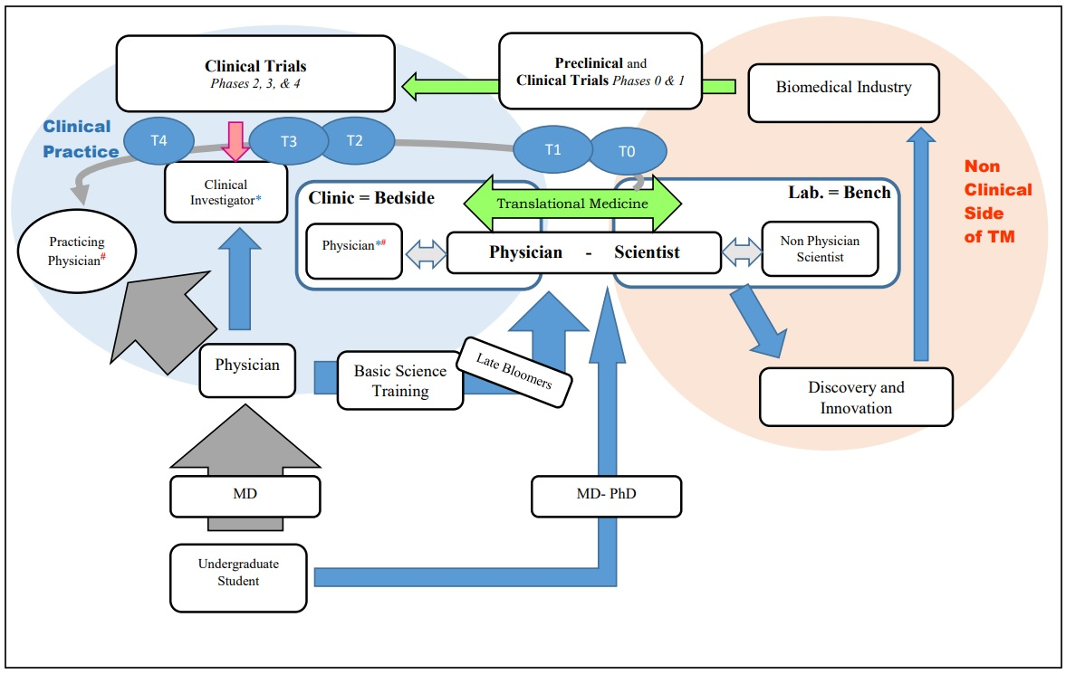
Fig. 2. The central role of physician-scientist in translational medicine. The physician (either clinical investigator or practicing physician) and the physician-scientist are connected by a double-pointed arrow, signifying that they communicate using the same language. Also, the non-physician scientist and the physician-scientist are joined by a double-pointed arrow, indicating that they speak the same language. The double-pointed arrow surrounding translational medicine indicates that translational medicine is a two-way road; from bench-to-bedside and from bedside-to- bench. In this encouraging scientific atmosphere, the laboratory is able to generate discoveries and create inventions that are later accepted by the biomedical industry to support clinical trials at different phases and finally delivered to the practicing physician for use in clinical practice. M.D.; (Doctor of Medicine) is the degree awarded after four years of undergraduate medical education (In USA, and some other countries). Ph.D.; (Doctor of Philosophy) is the most common degree at the highest academic level, awarded following a course of study and research. TM; translational medicine.

Figure 2 shows the central role of physician-scientist in translational medicine.
The ability of physician-scientists to act as both intra- and inter-professional translators is a significant characteristic that sets them apart from pure physicians and scientists. It is crucial that individuals from the bench and the bedside communicate with one another and have a shared understanding. Both groups can learn from one another since they each have unique talents and insights. The basic scientist lacks insights from clinical practice. Looking at the bedside, new questions may arise that could also be interesting for basic scientists. . The opposite is true, while looking at the bench. The most important thing is that these two groups understand one another. Just to mix creative minds and bring individuals from various areas together. ⁽¹²⁾
Additionally, physician-scientists are able to translate between research and clinic by playing a hybrid role in which they simultaneously practice and manage medical tasks (such as patient care and management) and research tasks (e.g., pipetting and preparing mouse models). As a result, they not only serve as a link between various research groups (inter-professional translation), but they also combine different professional tasks into one person (intra-professional translation). ⁽¹²⁾
Physician-scientists act as catalysts for translational research.⁽²⁶⁾ If we look at the model country in this context, which is the United States, we find that after developing and nurturing generations of physician-scientists at the beginning of the 20th century,⁽⁷⁾ discoveries and innovations began to be achieved, in the US, beginning in the 1940s.⁽⁵⁾ Physician-scientists were successful in winning Nobel Prizes in both medicine and other fields (such as chemistry and physics).⁽¹⁷⁾ On the other hand, Non physician scientists working in the medical field contributed to research at a faster rate, and several of them were awarded the Nobel Prize in Medicine.⁽⁵⁾ Additionally, the majority of clinical trials globally are conducted in the United States, and it goes without saying that American clinical investigators have risen to the top of the field as principal investigators in the most significant and illustrious clinical trials.⁽³⁰⁾ As shown in the figure 2, clinical investigators predominate in T2, T3 and T4.
As a whole, physician-scientists collaborations enhance patient care, advance medical education, and improve the biomedical industry's profitability.⁽²⁶⁾

The Valley of Death: when the physician-scientist's central position wane.
Despite extensive efforts made in the USA to support physician-scientists and a considerable rise in NIH funding on medical research, discoveries made in the lab have not led to an equivalent increase in new medications and cures. Instead, laboratory breakthroughs continue to remain in the "valley of death," or the gap between bench research and clinical application. One reason for this phenomena is the shrinking contribution of physician-scientists to the medical research sector, which has slowed the effective translation of laboratory advances into novel clinical applications.⁽³¹⁾
This is the case in a leading country in the field of translational medicine and development of physician-scientists. Let's try to imagine how things might be in developing countries.

Future perspective
Egyptian faculties of medicine must intensify their efforts in the field of translational medicine by mentoring and educating aspiring physician-scientists and building on the achievements of other countries in this field. The infrastructure related to translational medicine must be reviewed and developed. For medical faculty members, a variety of promotion tracks must be developed, the majority of which must guarantee their continued engagement in translational medicine and innovation. To achieve the intended goal, the Egyptian Ministry of Health must assess the role performed by comparable organizations internationally and decide the best ways to work with Egyptian academic medical centers.

References
1. Waraich M, Shah S. The life and work of Jean-Martin Charcot (1825-1893): 'The Napoleon of Neuroses'. J Intensive Care Soc. 2018;19(1):48-9.

2. Mazzarello P. Camillo Golgi (1843-1926). J Neurol Neurosurg Psychiatry. 1998;64(2):212.
3. Schafer AI. 1. History of the Physician as Scientist. In: Andrew IS, editor. The Vanishing Physician-Scientist? Ithaca, NY: Cornell University Press; 2011. p. 17-38.

4. Lakhtakia R. A trio of exemplars of medieval islamic medicine: Al-razi, avicenna and ibn Al-nafis. Sultan Qaboos Univ Med J. 2014;14(4):e455-9.

5. Kantha SS. A review of Nobel prizes in medicine or physiology, 1901-87. The Keio journal of medicine. 1989;38(1):1-12.

6. Daye D, Patel CB, Ahn J, Nguyen FT. Challenges and opportunities for reinvigorating the physician-scientist pipeline. J Clin Invest. 2015;125(3):883-7.

7. Coller BS. 4. Translational Research and the Physician-Scientist. In: Andrew IS, editor. The Vanishing Physician-Scientist? Ithaca, NY: Cornell University Press; 2011. p. 67-83.

8. Brass LF, Akabas MH. The national MD-PhD program outcomes study: Relationships between medical specialty, training duration, research effort, and career paths. JCI Insight. 2019;4(19).

9. Alamri Y. The combined medical/PhD degree: a global survey of physician-scientist training programmes. Clinical medicine (London, England). 2016;16(3):215-8.

10. Varki A, Rosenberg LE. Emerging opportunities and career paths for the young physician-scientist. Nature medicine. 2002;8(5):437-9.

11. Williams CS, Rathmell WK, Carethers JM, Harper DM, Lo YMD, Ratcliffe PJ, et al. A global view of the aspiring physician-scientist. eLife. 2022;11.

12. Hendriks B, Simons A, Reinhart M. What are Clinician Scientists Expected to do? The Undefined Space for Professionalizable Work in Translational Biomedicine. Minerva. 2019;57(2):219-37.

13. Ginsburg D. The history and evolution of the ASCI: deja vu all over again. American Society for Clinical Investigation. J Clin Invest. 2002;110(12):S1-4.

14. Pisetsky DS. Gamow, Guppies, and the Search for GOD. In: Schwartz DA, editor. Medicine Science and Dreams: The Making of Physician-Scientists. Dordrecht: Springer Netherlands; 2011. p. 15-32.
15. Yang VW. The future of physician-scientists-demise or opportunity? Gastroenterology. 2006;131(3):697-8.

16. Rosen MR. The role of the physician-scientist in our evolving society. Rambam Maimonides medical journal. 2011;2(4):e0063.

17. Schafer AI. Introduction. In: Andrew IS, editor. The Vanishing Physician-Scientist? Ithaca, NY: Cornell University Press; 2011. p. 1-16.

18. Garrison HH, Ley TJ. Physician-scientists in the United States at 2020: Trends and concerns. FASEB journal : official publication of the Federation of American Societies for Experimental Biology. 2022;36(5):e22253.

19. Brown NJ. Developing physician-scientists: a perspective. Transactions of the American Clinical and Climatological Association. 2013;124:218-29.

20. Schwartz DA. Physician-Scientists: The Bridge between Medicine and Science. American Journal of Respiratory and Critical Care Medicine. 2012;185(6):595-6.

21. Salto-Tellez M, Oh VM, Lee EH. How do we encourage clinician scientists in Singapore? Ann Acad Med Singap. 2007;36(11):879-80.

22. Wyngaarden JB. The Clinical Investigator as an Endangered Species. New England Journal of Medicine. 1979;301(23):1254-9.

23. Goldstein JL. On the origin and prevention of PAIDS (Paralyzed Academic Investigator's Disease Syndrome). J Clin Invest. 1986;78(3):848-54.

24. Luz PLD, Laurindo FRM. Translational Medicine and Implementation Science: How to Transform What We Know Into What We Do. Arq Bras Cardiol. 2022;119(2):342-5.

25. Lindahl S, Marincola F. translational medicine. Encyclopedia Britannica2023.

26. Archer SL. The making of a physician-scientist--the process has a pattern: lessons from the lives of Nobel laureates in medicine and physiology. Eur Heart J. 2007;28(4):510-4.

27. Wong TY. How to bridge the "valley of death" between a research discovery and clinical application? Ann Acad Med Singap. 2014;43(8):422-4.

28. Alving B, Dai K, Chan SHH. The What and Why of Translational Medicine. In: Alving B, Dai K, Chan SHH, editors. Translational Medicine - What, Why and How: An International Perspective. 3: S.Karger AG; 2012. p. 0.

29. Myles Akabas, Lawrence Brass, Tartakovsky I. National MD-PhD Program Outcomes Study. Association of American Medical Colleges; 2018.

30. Marshall IJ, L'Esperance V, Marshall R, Thomas J, Noel-Storr A, Soboczenski F, et al. State of the evidence: a survey of global disparities in clinical trials. BMJ global health. 2021;6(1).

31. Roberts SF, Fischhoff MA, Sakowski SA, Feldman EL. Perspective: Transforming science into medicine: how clinician-scientists can build bridges across research's "valley of death". Academic medicine : journal of the Association of American Medical Colleges. 2012;87(3):266-70.

